Project Design Phase-II Technology Stack (Architecture & Stack)

|  |  |
| --- | --- |
| Date | 16 November 2022 |
| Team ID | PNT2022TMID33204 |
| Project Name | Project – AI-Powerd Nutrition Analyzer for Fitness Enthusiasts |
| Maximum Marks | 4 Marks |

# Technical Architecture:

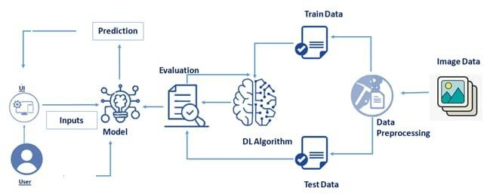

# Table-1 : Components & Technologies:

|  |  |  |  |
| --- | --- | --- | --- |
| **S.No** | **Component** | **Description** | **Technology** |
| 1. | User Interface | Through a web UI, the user can engage with the application. | HTML, CSS, JavaScript / Angular Js / React Js etc. |
| 2. | Application Logic-1 | It has many in built libraries which helps in machine  learning | Python |
| 3. | Application Logic-2 | It helps to build machine learning model | IBM watson jupyter notebook service |
| 4. | Application Logic-3 | It is fast and accurate | IBM Watson Assistant |
| 5. | Database | MySQL is used to store the user information and  warehouse the food items | MySQL |
| 6. | Cloud Database | IBM Db2 is reliable and scalable | IBM DB2 |
| 7. | File Storage | Maintain files easily | Local Filesystem |
| 8. | External API-1 | Aadhar and customer KYC verification takes a little  amount of time | Aadhar API, etc. |
| 9. | External API-2 | To recognise the patterns and trend | Aadhar API, etc. |
| 10. | Machine Learning Model | Purpose of Machine Learning Model | Sequential, Dense& LSTM Model |
| 11. | Infrastructure (Server / Cloud) | Application Deployment on Local System / Cloud Local Server Configuration:  Cloud Server Configuration : | Local system and IBM watson |

**Table-2: Application Characteristics:**

|  |  |  |  |
| --- | --- | --- | --- |
| **S.No** | **Characteristics** | **Description** | **Technology** |
| 1. | Open-Source Frameworks | Tensor flow-Implements model building and training. Flask- Can handle multiple user request simultaneously. Scikit learn-Contains model for  classification, regression, clustering | Tensor flow, flash, Scikit learn. |
| 2. | Security Implementations | SHA-256 doesn't have any  known vulnerabilities | SHA-256 |
| 3. | Scalable Architecture | MySQL can store huge amount of  data and it Is easily scalable | MySQL |
| 4. | Availability | This application can be accessed from anywhere  easily and it is easily scalable. | IBM Waston cloud |
| 5. | Performance | Flask can handle multiple user request  simultaneously. | Flask |